Posture
Good posture and good singing are strongly interrelated.
The body functions best when certain conditions exist.
Good posture allows the skeletal framework and muscular components of the body to fulfill their basic functions efficiently, without any undue expenditure of energy.
The actuator of the vocal instrument functions best when certain conditions exist.
Good posture allows the breathing mechanism- the actuator- to fulfill its basic function efficiently without any undue expenditure of energy.
The vibrator and resonators of the vocal instrument function best when certain conditions exist.
Good posture facilitates the functioning of the vibrator and resonators.
The singer functions best when certain conditions exist.
Good posture can be a psychological asset to a singer.
The audience functions best when certain conditions exist.
Good posture can help a singer secure a positive reaction from an audience.
The general health of an individual can be benefited by good posture.
Habitual good posture can relieve much of the tension and fatigue caused by sitting or standing improperly.

Adjectives to visualize for posture
buoyant, expansive, erect, alert, free-to-move, vibrant, flexible, poised, tall, loose, free, happy, balanced.
Using a mirror is one of the quickest and most effective means of correcting postural faults and mannerisms. If you can satisfy yourself, you can satisfy most audiences.
Tension is probably the greatest enemy of the public performer.
1. Learn where excess tension is likely to occur and be alert for it
2. Loosen up the body and make certain it is functioning properly before you attempt to practice or perform.

Stretching Exercises Before Singing
1. Begin with general bending and stretching
A) Reaching as high as you can, touching the left foot with the right hand and right foot with the left hand.
B) Rolling the body around in circles from your waist
C) Deep knee bends
D) Touching both toes simultaneously
2. Roll your head around gently in circles clockwise several times and then reverse the direction.
3. Move your shoulders around in circles, first to the back and down several times, then reverse the direction.
4. With your arms handing loosely at your sides, shake your hands back and forth as fast as you can while keeping your upper arms as loose as possible.
5. Stand with your feet close together and without lifting your toes from the floor, raise each heel alternately as if you’re walking in place, gradually increasing the tempo until your legs seem to be shaking all over.
6. Nod your head back and forth gently.
7. Flop your jaw up and down freely while saying “yah”, gently rub the muscles around the jaw joint on each side of your face and stroke downward toward your chin.
8. Bubble air between your lips until you are making a sound resembling that of a motorboat or motorbike- lip trills.
9. Pretend you are chewing a large bite of food.
10. While standing tall, start bending over slowly, letting the head lower first, then rolls the shoulders forward as if you are trying to stretch the spine and separate each vertebra from the one below it until you are fully bent over. Stay in this position a few seconds and breathe deeply, being conscious of where you feel expansion, then reverse the process, returning to the upright position as slowly as you can; repeat the exercise several times. Note how free your posture feels afterword.

Proper Posture- Toe to Head
The Feet- weight should be evenly distributed between the feet; the weight should be toward the balls of your feet. This should look natural and feel good.
The Legs- Should be freely flexible and ready to move at all times. Avoid any sensation of rigidity of being locked.
The Knees- Should feel loose and be ready to move at all times. May be kept slightly bent to avoid locking.
The Hips and Buttocks- Neither hip should stick out further to one side than the other and the buttocks should be gently tucked under and forward as if you’re trying to straighten the small of your back.
The Abdomen- Lower should be gently pulled in. The upper should feel free to move at all times.
The Back- Imagine standing as tall as you can.
The Chest- Should be comfortably high at all times. Should feel expanded, spacious, and buoyant.
The Shoulders- Should be rolled or pulled back gently and then allowed to drop down until they feel as if they have settled into a socket. When the shoulders remain stationary, it is much easier to maintain the comfortably high chest and the feeling of spinal stretch. Avoid any sensation of rigidity or locking.
The Arms and Hands- Should hang freely and naturally at your sides. Should be free from tension. Avoid nervous clenching of your fists, rubbing your thumbs and fingers together, feeling your clothes, twitching your hands or fingers, and tensing your arms. All of these tend to be distracting to an audience. You may also hold your hands in front of your body.
The Head- Should be directly in line with the body and centered on the shoulders. Eyes should appear level. Chin is slightly tucked. When you are singing your head and eyes should remain level, avoid raising the chin to reach high notes; chin can be slightly lowered to reach high notes.
Seated Posture- From the hips up you should feel almost the same as you did when you were standing. The trunk and head should be in a straight line, with the feeling that you are sitting tall and stretching your spine. Your foot position should be the same as when you stand; this makes it possible to stand up without shifting your position.
Relaxing Your Lips
Lips must be free from tension and ready to move. They should be slightly off the teeth, as if you’re about to smile. Their movements should be quick, precise, and positive.
Imagine that your lips are made of rubber and that they bounce freely apart when contacting each other.
Tense lips have a strong effect on the color of your tone (they can make it sound harsh).
Although a slight smile is desirable, be careful not to pull your lips back off your teeth into a forced smile.
Pulling back on the lips can tighten the pharynx in the vicinity of the soft palate and can cause the tone quality to become too bright.
Pulling your lips in against your teeth or your upper lip down tends to darken the tone quality and make the voice sound muffled because of the restricted space.
A slight smile, the feeling that your lips are not touching your teeth may be beneficial. Try to feel that your lips are slightly off your teeth and free to move. When the lips are protruded, they resemble a megaphone and may help produce a loud, ringing tone that will carry a long way.
When you sing do you tense your lips? Are you exaggerating their movement or that of your cheeks or the opening of your mouth? Do you try to form your vowels with your lips?
Try this: Put on a recording of a song you like to sing or a backing track of a song you perform.
Stand in front of a mirror and watch yourself as you sing. Really put yourself into the song and watch your face, especially your lips and mouth. If you exaggerate the movement of your face as part of achieving the notes, this tension will back up into your throat and you will find yourself pushing against this tension.
Remedy: Gently place the palms of your hands against the right and left cheeks of your face just to the sides of your mouth. Sing the song again and let your hands help you relax the movements of your lips, cheeks and mouth. Of course there will be some movement but we are working to have it be relaxed and natural, not excessive.
Does that feel better? Do you notice a difference in how you sound? It should feel easier to sing and it sound better.
Facial movements are a natural expression of your emotions; just don’t use them to try to get vocal sound.

Food & Singing
YOU ARE YOUR VOICE...TAKE CARE OF IT!
Your singing voice greatly depends on your body stamina. Stamina comes fromenergy. If you have no energy your voice is adversely affected. The foods you eatgreatly influence your voice and singing performance. Your body and mind are yourinstrument. You must take care of your body like any other instrument.

BAD FOOD

Cigarettes: Dries out your vocal cords...
Dry cords cause you to push excessively, which results in a strained and hoarse voice.

Alcohol: Dries out your vocal cords...
Dry cords from alcohol will cause you to push too hard on the larynx, which results in a strained voice
Milk & Dairy: Create excessive phlegm…
The singer constantly clears the throat, which slam the cords together, causing irritation and unnecessarystrain and hoarseness.

Large Meal: Rule of Thumb…
Do not eat within one and a half hours of performance time. Digestion makes you sluggish and takesaway energy. Eat protein for this meal.

Grapes: Grapes cause water retention…
Eating a lot of grapes before singing causes bloating and abdominal cramping

Sweets: Sweets and sugar….
Especially candy will give you a spurt of energy - this "rush" will last only about a half an hour and thendrops suddenly leaving you extremely low on energy.
Oranges: Eating an orange…
Before you sing has the same affect as dairy foods. It causes phlegm. Orange juice does even more so.
Junk Food: Yuck Food…
Gives you a heavy feeling. You’re full but you get immediately sleepy. There is no protein in junk food and you get no energy from it.
Menthol: Cough drops…
Will dry you out. Use cough drops or lozenges without menthol, like Ricola.

GOOD FOOD
Protein: Almonds, eggs, tuna…
These are all excellent types of protein. Protein gives you lasting energy!

Fruits & Vegetables: A good balance…
of carbohydrates and protein will give a lasting burst of energy for a long gig or performance.

Water: Drink water regularly…
Hydrate your body all the time. Drinking water just the day of performance will not keep your body andvocal chords hydrated. Water is good for your health.
Apples: Eat some…
Apples have both fiber and pectin. Both are good for you. They help keep your mouth and throatmoisturized. If you are tired, eat an apple for an instant burst of energy.

Drinking herbal tea with honey and lemon…
Make sure the tea is warm and not hot, the closer to body temperature the better. The lemon can cut down on phlegm and the honey can coat your throat, all helping in the health and strength of your vocal chords. If you don’t like tea, simply drinking warm water with these will do the same trick! Two great herbal teas for singers are Throat Coat and Throat Comfort.

Ten Steps Toward Vocal Health

- Drink lots of water
- Get plenty of rest
- Quit smoking
- Eat right
- Exercise
- Laugh
- Take care of illnesses
- Get plenty of rest
- Use a supported speaking voice
- Balance voice use with voice recovery time

Physicality
BUILDING ENERGY AND STAMINA - CORE MUSCLES
WHAT ARE THE CORE MUSCLES?
The spine itself is just bones stacked on top of one another, and in between the bones—to cushion them—are small discs. The core of each disc has the texture of cheese, and it is surrounded by tough fibrous tissue. To make the spine more stable, the parts are all connected with layers of soft tissue such as cartilage and ligaments. They are also connected by muscles. If these muscles are strong and working in the proper order, you have a solid base for movement and for absorbing the impact of the ground through your body. You will have the ability to stand on the risers for long periods of time without getting tired. Your choreographic moves will be more convincing and solid. You will be able to increase your breath control and be able to hold phrases longer even while you are doing choreographic moves. The main muscles involved in core stabilization are deep muscles such as the transverse abdominus, the multifidus, and the muscles of the pelvic floor. The transverse abdominus is like a corset around your abdomen. It’s the muscle you work if you pull in your stomach. This is the muscle you feel when coughing. The multifidus is a muscle that lies along your spine from your neck to your pelvis, with short fibers connecting one bone (vertebra) of the spine to other vertebrae near it. The muscles of the pelvic floor are most noticeable when you squeeze to keep yourself from urinating. Other core muscles include are the outer front, back, and hip muscles. When doing core-building exercises remember to also work the thighs and buttocks. Every time we move, we depend on some muscles to hold us steady and other muscles to actually move us. Core stabilization is the general term for how the muscles of your trunk keep your spine and body stable. This helps you stay balanced when you move. If your core muscles are strong and they contract when they should:

- Your body is balanced.
- Your movement is more efficient and powerful.
- You may be less likely to be injured.
- You have the stamina to sing and perform
- Your posture is better.

Core stability benefits everyone, from older people to top professional athletes. Exercises for core stabilization can be part of every conditioning program, along with flexibility, strength, and aerobic training.

HOW CAN I INCREASE MY CORE STRENGTH AND STABILITY?
Core stabilization exercises are easy to do. You don't need any equipment for these exercises, and you don't need much space. You can do them almost anywhere, several times each day, to start increasing your core stability. It's more important that you do core exercises well than that you do a lot of them. As you exercise, focus on the muscles you are using and tune in to your body and how it feels. Concentrate on using the right muscles and breathe normally while you do the exercises. Then he or she can help you learn more challenging core stabilization exercises.

BREATHING
When you exercise, you should breathe mostly with your diaphragm, the large muscle that helps move air in and out of your lungs. To learn to breathe with your diaphragm, lie down on your back and put your hand on your stomach. When you breathe in and out, your hand should move up and down. Notice how it feels to breathe this way. When you start to exercise, try to get the same feeling of your chest and abdomen moving in and out as you breathe, rather than your chest and shoulders moving up toward your neck and back down. This not only works for exercising but also when you are singing.

ALIGNMENT – NEUTRAL SPINE
• Keeping your pelvis in this neutral, forward position; stand tall with your ears and shoulders lined up over your hips.
• Practice finding neutral spine in three positions: standing, sitting, and lying on your back with your knees bent.
• When you can find neutral spine in each position, you can maintain good posture for daily activities, exercise, and singing.

EXERCISE
Do some sort of moderate aerobic activity, like brisk walking, for at least 2½ hours each week. You can spread out these 150 minutes any way you like. For example, you could:
• Take two 11-minute walks every day or a single 22-minute walk every day.
• Take a half-hour walk 3 days a week, and on the other 4 days take a 15-minute walk.
• Take a 45-minute walk every other day.
• When you walk, add interval exercises like running for one – two blocks, jog or jump rope inplace, or do push -ups on a park bench

Diagrams & Anatomy of the Voice
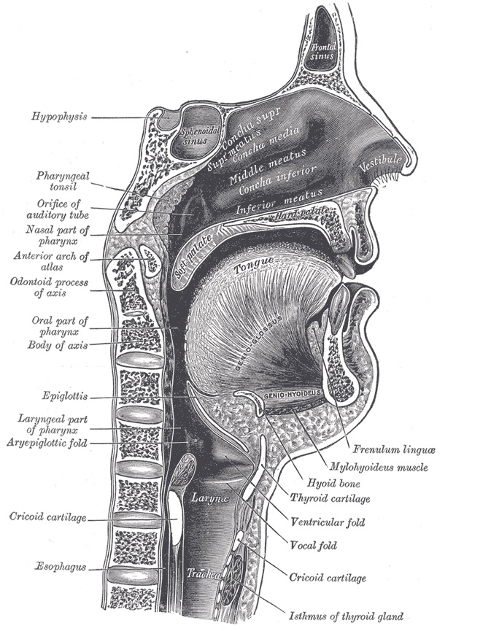
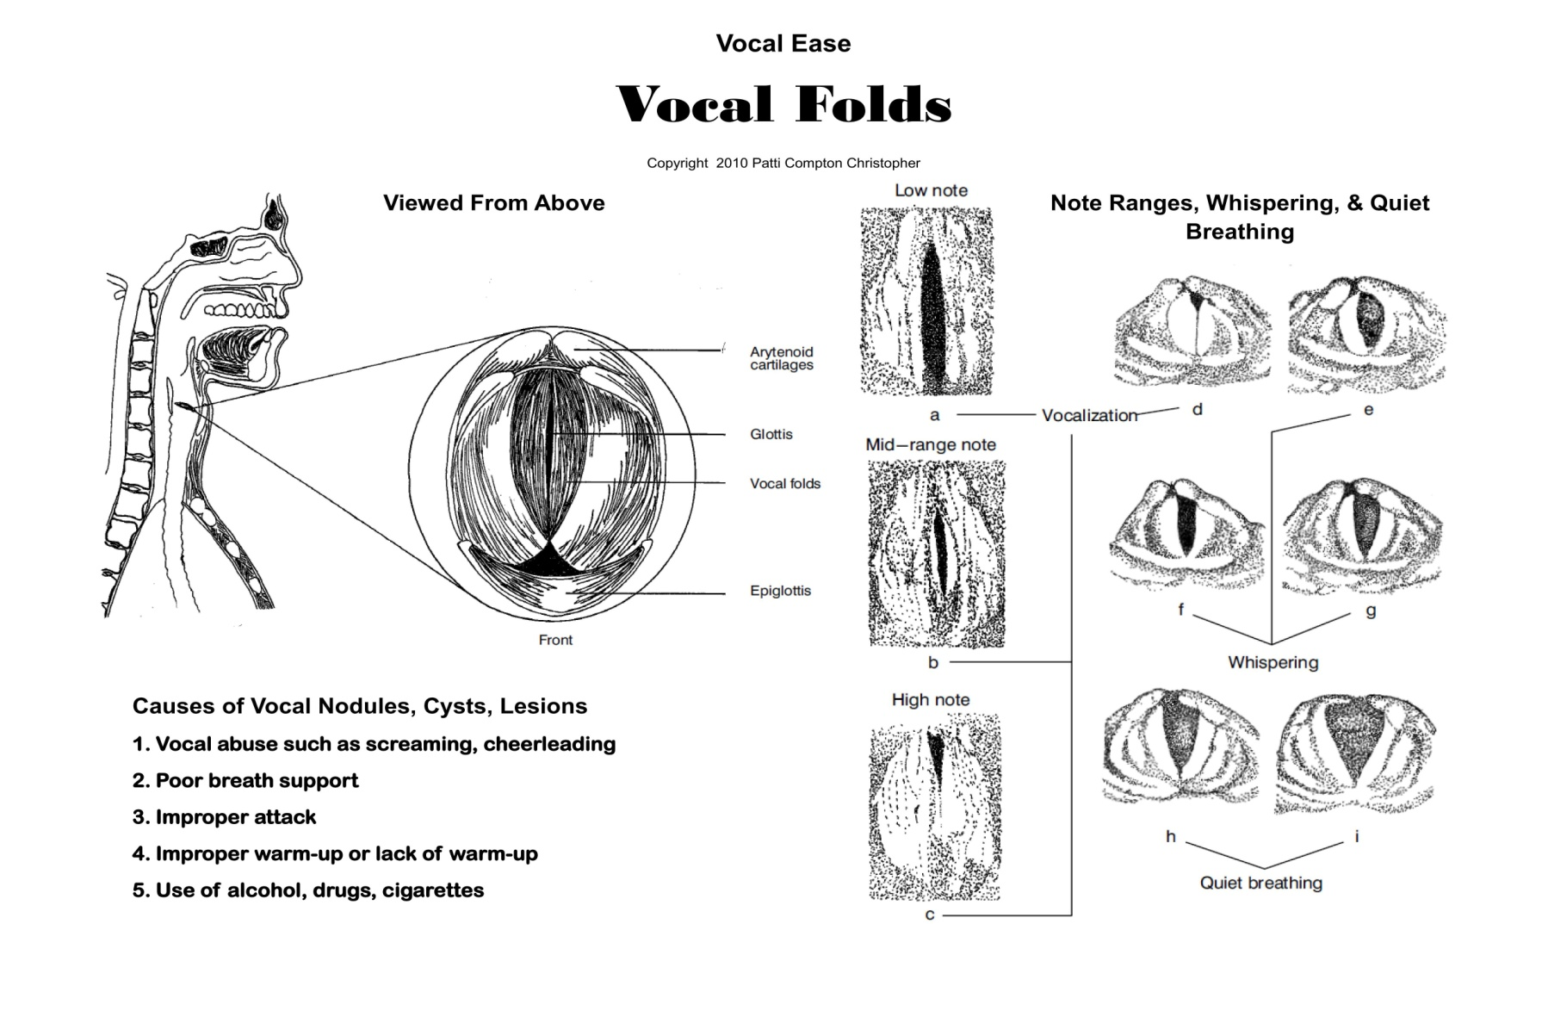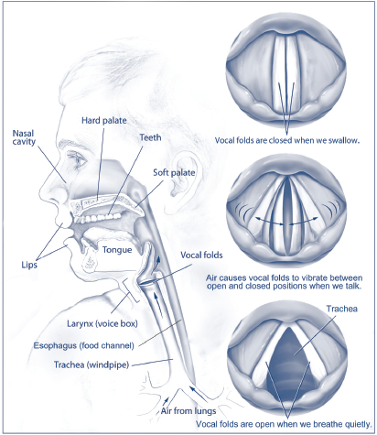
How to Properly Breathe
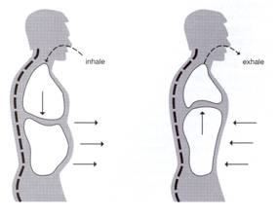
Breathe in, expand belly & diaphragm Breathe out, bring belly and diaphragm in toward spine
Easy way to remember:
Breathe IN- Belly OUT
Breathe OUT- Belly IN

